***Lab 14 –Testing & Deployment***

*Open Visual Studio by right clicking on the icon > Select Run as Administrator*

**

*Create a New Project >Select Empty Template > Check MVC reference folders > check Add unit tests > Ok*

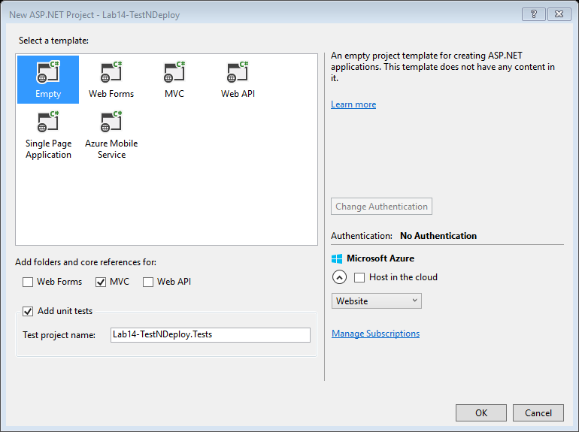

*Add a HomeController > Index action method should call for HomePage.cshtml:*

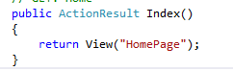

*Add View and Name view as HomePage > Run your code and check.*

*Add another action method in the Home Controller which passes a ViewBag.Message*

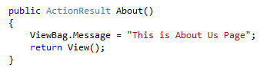

*Add view for About and write the following code:*

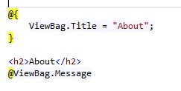

*Add another method to integrate maps:*

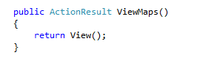

*Add view for ViewMaps and we shall intergrate the Google maps here:*

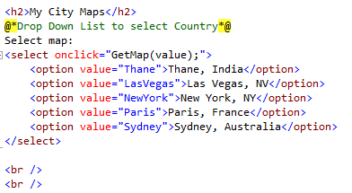

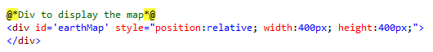

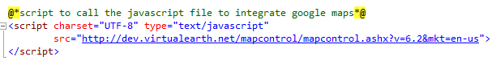

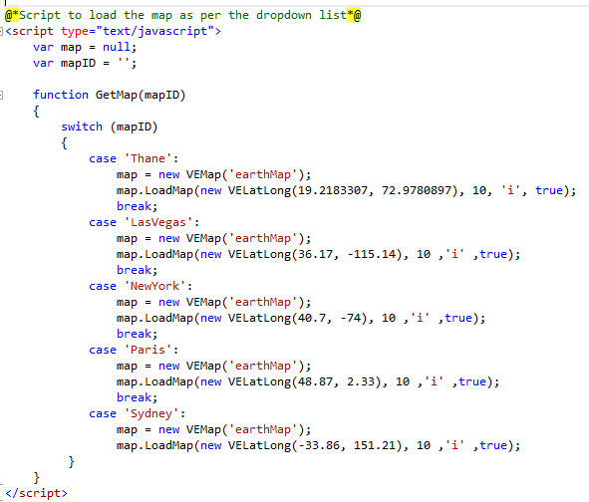

*Go to _Layout.cshtml and add the following links:*

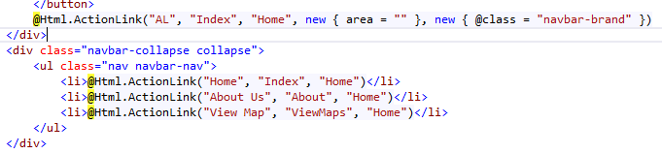

*Now we shall check the how to test all the methods:*

*Right click on the Tests project > Add > New Item > Select Test in the left pane > Basic Unit Test > Rename the file to “HomeControllerTest.cs” > Add*

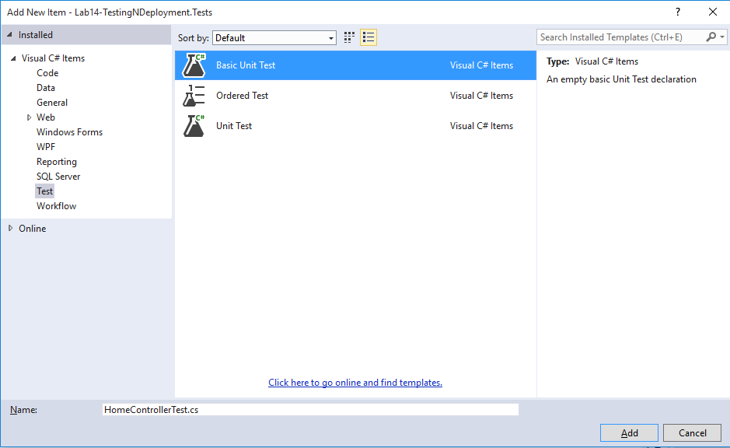

*Now the following code gets created:*

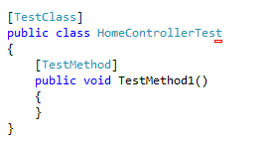

*Now we shall implement code to test all our Action methods of HomeController:*

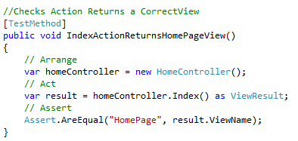

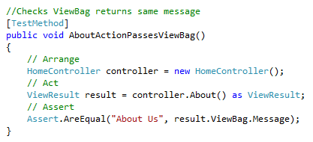

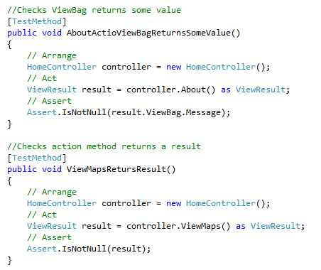

*How to test the Code:*

*Select Test > Run > All Tests*

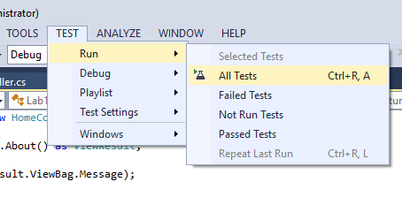

*In the TestExplorer you will be able to view all the TestMethods*

***Code can be deployed in two ways:***

*Note: For deploying in both the ways Activate the IIS on your computer. Following are the steps:*

* *Go to Control Panel > Program & Features > Turn Windows Features on Or off*

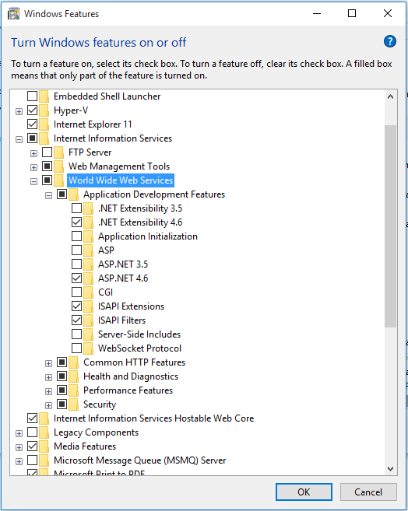

* *Check IIS (Internet Information Services) and expand, specifically expand World Wide Web Services > expand Application Development Features > check ASP.NET 4.5 or above > Click OK*
* *It will change the settings.*
* *To verify the settings are properly implemented or not, Press Window + R (Start the Run) > type inetmgr > OK*

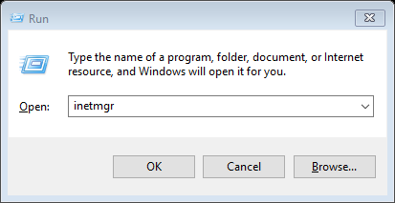

*IIS Manager will open:*

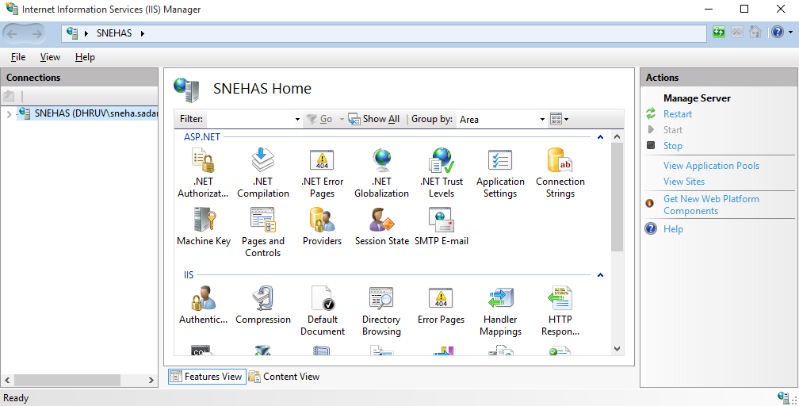

*Now we are all set to deploy the code:*

***Way 1:***

*Right click on the project > select properties > Properties page shall be opened > go to web > under servers from the dropdown list select “Local IIS” > Change project URL if you wish to > Click on Create Virtual Directory Button > Directory created message will be shown.*

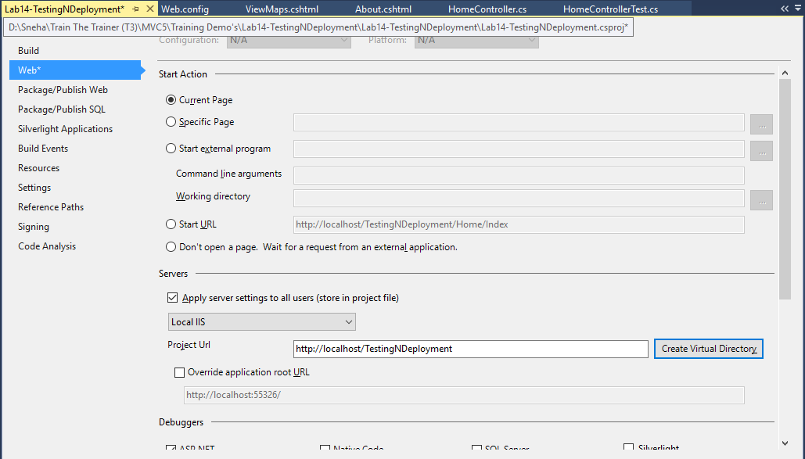

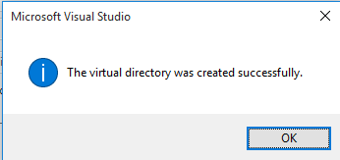

*Now go to IIS Manager and refresh Default Web Site under Connections. Your Project Name will appear.*

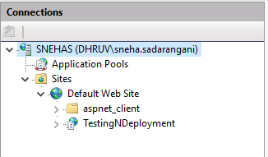

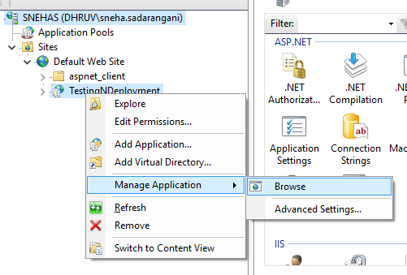

*Right click on TestingNDeployment > Manage Application > Browse. Your project will appear.*

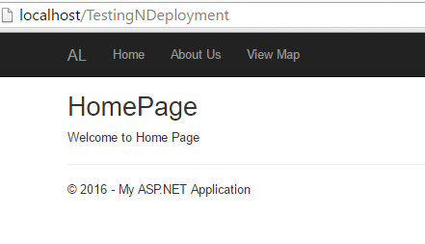

***Way 2:***

*Right click on the project > Select Publish*

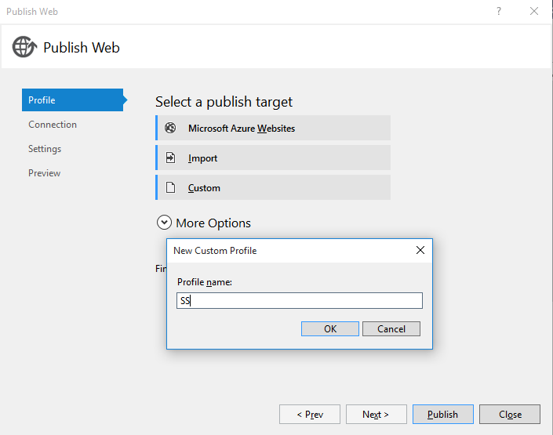

*Click on Custom > Add Profile Name = SS > Click OK*

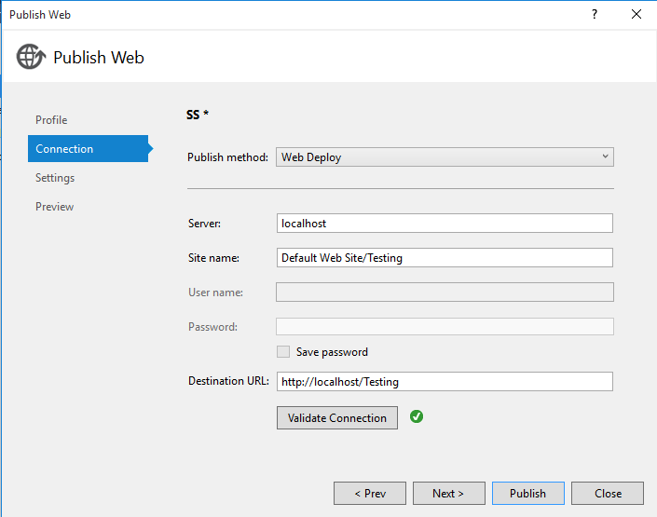

*Click on Publish*